2 a) Step 1: A jenkins ecosystem with one master and two slave nodes have setup.

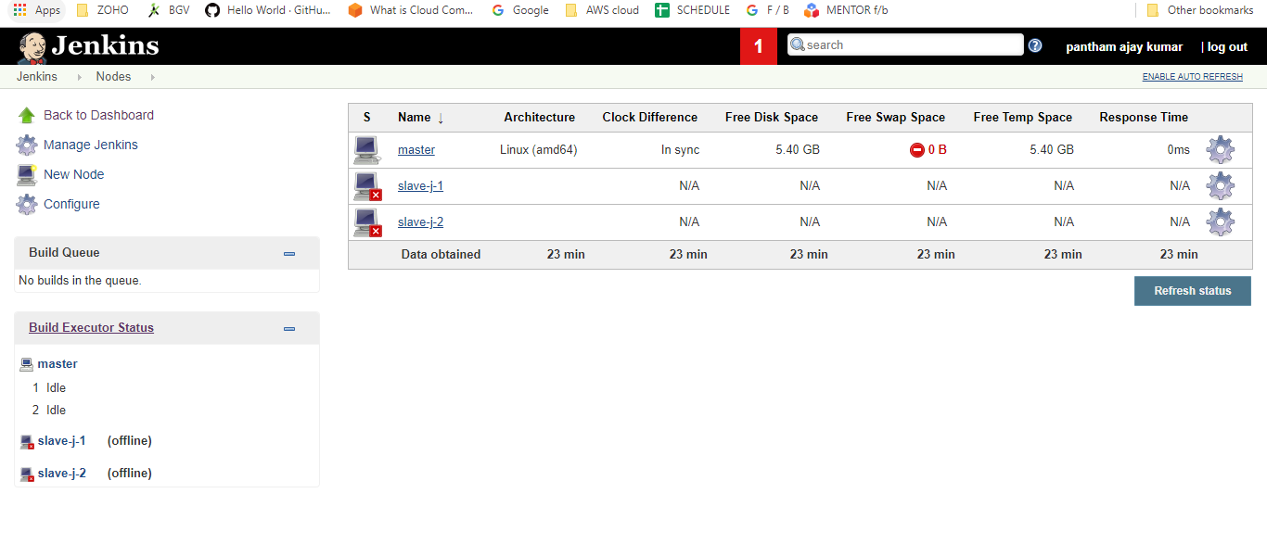

- setup a CICD pipeline which in build step fetches a file from git repo and pushes it to a bucket in the deploy step.
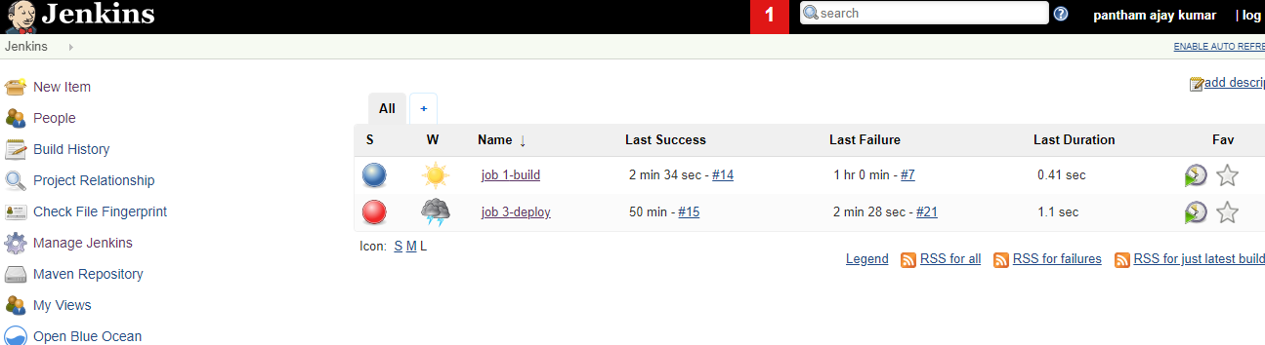

- Two seperate jobs ( build and deploy ) are setup and made them
together as pipeline by making the job-1(build) as trigger to job-2(deploy)
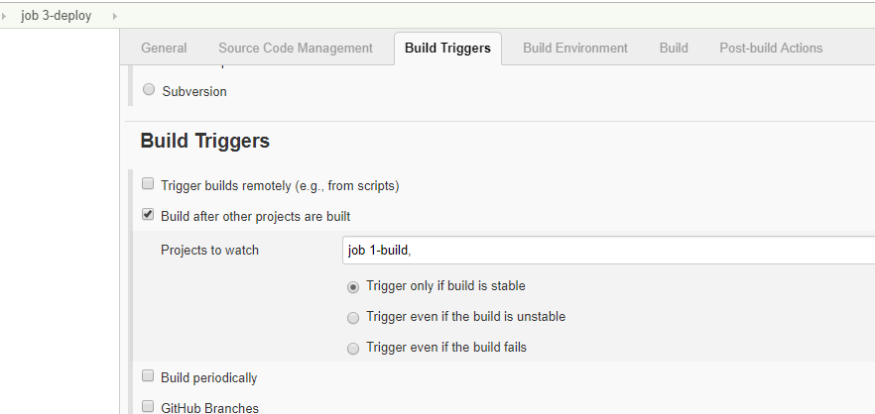

Build step:
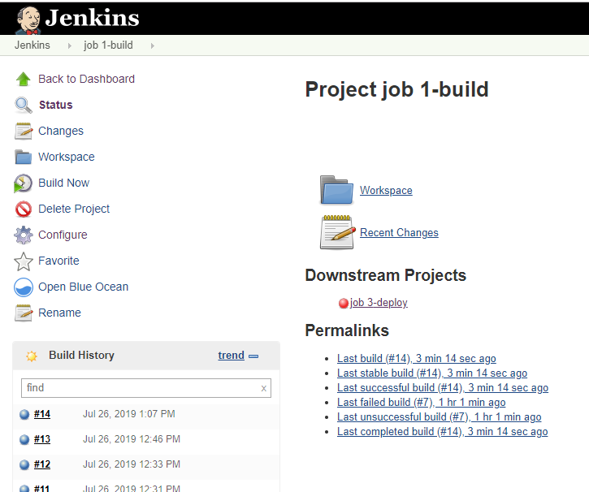

- In build job, a file from the given git repository is fetched.

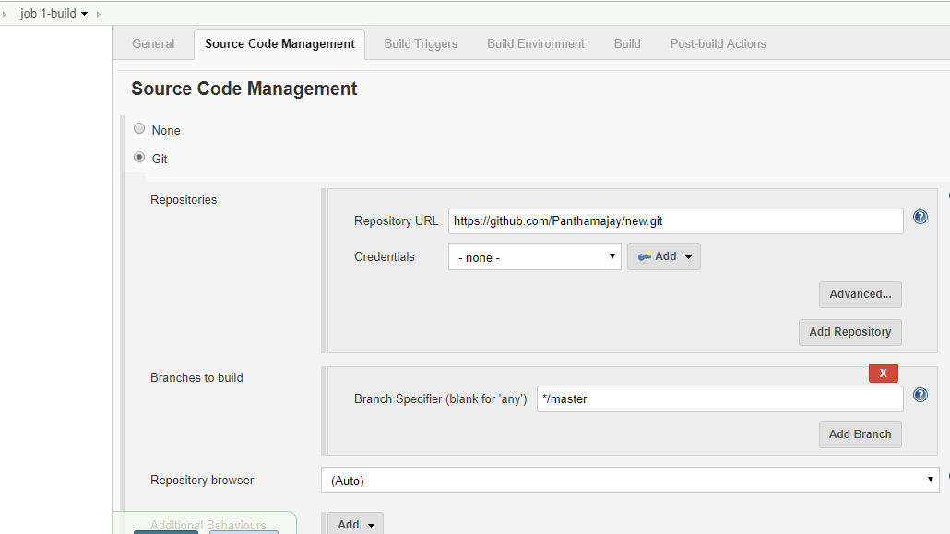

The fetched file from git repository gets stored under workspace.



5.Deploy job:

In this step, the file fetched from git is deployed into AWS S3 bucket.

Since we set build job as trigger to deploy stage,

here the up stream project : build job

Downstream project : deploy job.

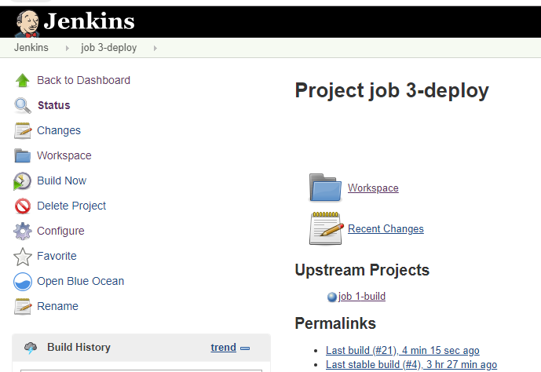

In the deploy step,

- artifacts from the workspace of build job are copied to deploy job so that they can be deployed in s3 bucket.

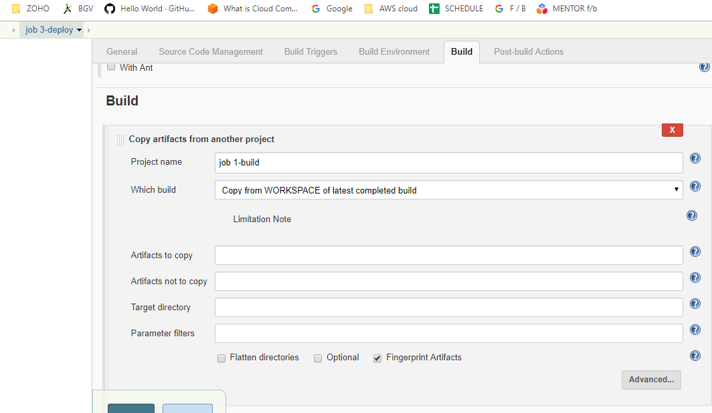

,

- A s3 profile is created and assigned to deploy job.

- The s3 bucket name and its region is provided.

4. IAM role with full s3 access is assigned to jenkins server (master ec2 )
5. The s3 bucket has opened to public access such that the deploy job can deploy the file into the bucket.

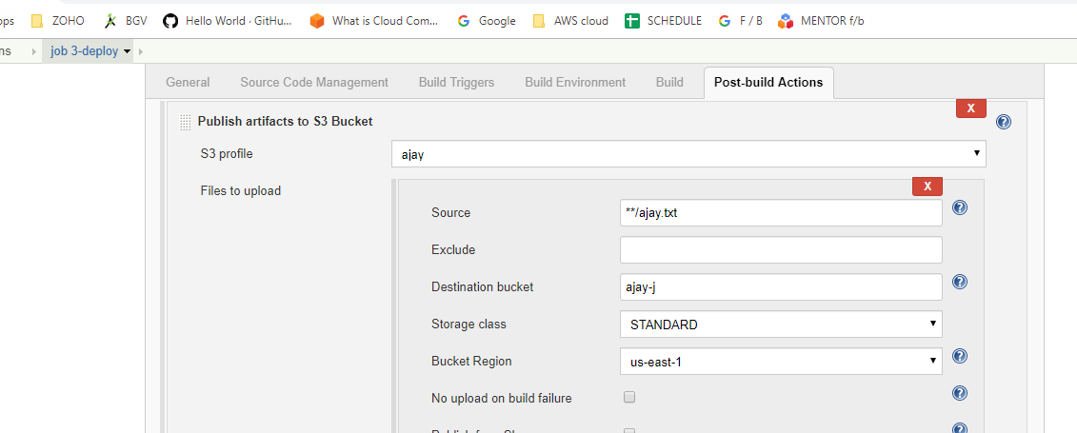

6 Finally, when we run build on build job , it triggered the deploy job thus deployed a file into s3 bucket

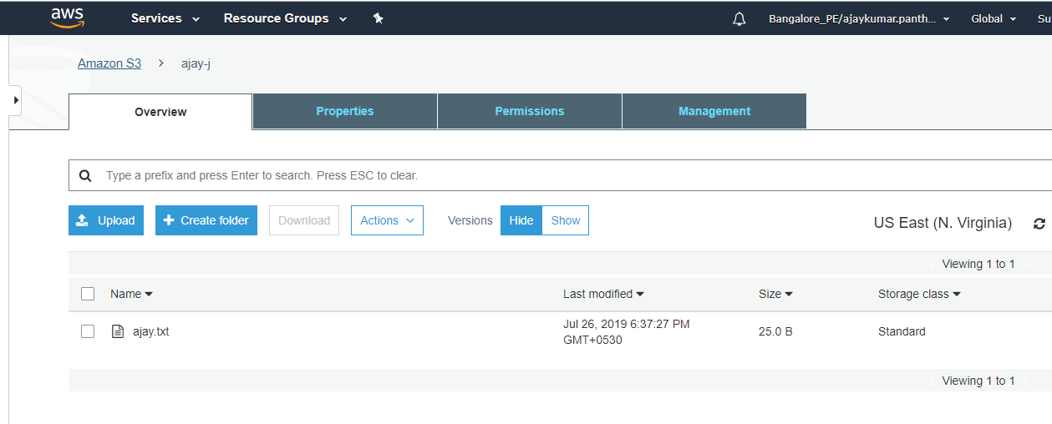

2 b) Pipeline script to compile the CFT template:

pipeline{
agent{
node{
label 'master'
}
}
stages{

stage('git clone'){
steps{
sh 'sudo rm -r *;sudo git clone https://github.com/Panthamajay/new.git'
}
}
stage('CFT'){
steps{
sh 'ls'
sh 'pwd'

sh 'aws cloudformation create-stack --stack-name createec2 --template-body /var/lib/jenkins/workspace/Multi_pipe_master/Jenkins_sample/cerate_ec2_cft.json --region us-east-1'
}
}

}

}

JSON code for ec2 instance in github (CFT template):
{
"AWSTemplateFormatVersion" : "2010-09-09",
"Resources" : {
"WebServerInstance": {
"Type" : "AWS::EC2::Instance",
"Properties": {
"ImageId" : "ami-0b898040803850657"
"InstanceType" : "t2.micro",

}
}
},

"Outputs" : {
"WebsiteURL" : {
"Value" : { "Fn::Join" : ["", ["http://", { "Fn::GetAtt" : [ "WebServerInstance", "PublicDnsName" ]} ]]},
"Description" : "WordPress Website"
}
}
}
2 c) Pipeline script for approve step before deployment:

pipeline {
environment {
BRANCH_NAME = "${env.BRANCH_NAME}"
}
agent any
stages{
stage('Build-Initiator-Info'){
steps{
sh 'echo "Send Info"'
}
}
stage('Build') {
steps{
catchError {
sh 'echo "This is build"'
}
}
stage('git clone'){
steps{
sh 'sudo rm -r *;sudo git clone https://github.com/Panthamajay/new.git'
}
}
post {
success {
echo 'Compile Stage Successful . . .'
}
failure {
echo 'Compile stage failed'
error('Stopping early…')

}
}
}
stage ('Deploy To Prod'){
input{
message "Do you want to proceed for production deployment?"
}
steps {
sh 'echo "Deploy into Prod"'

}
}
}
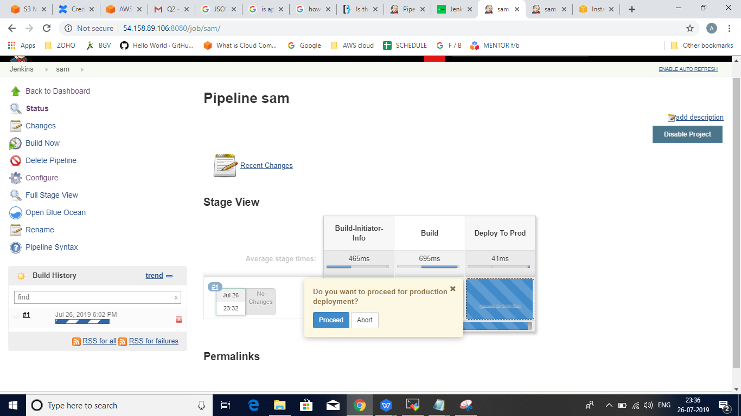

With the approval of whether to proceed further or not, the build continued in the above pipeline process.

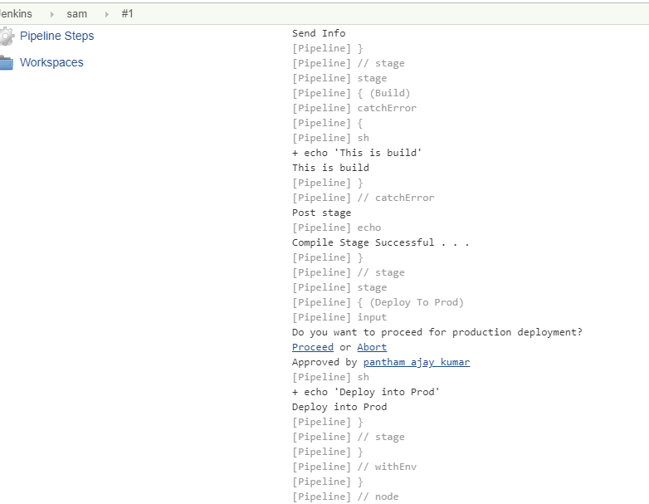

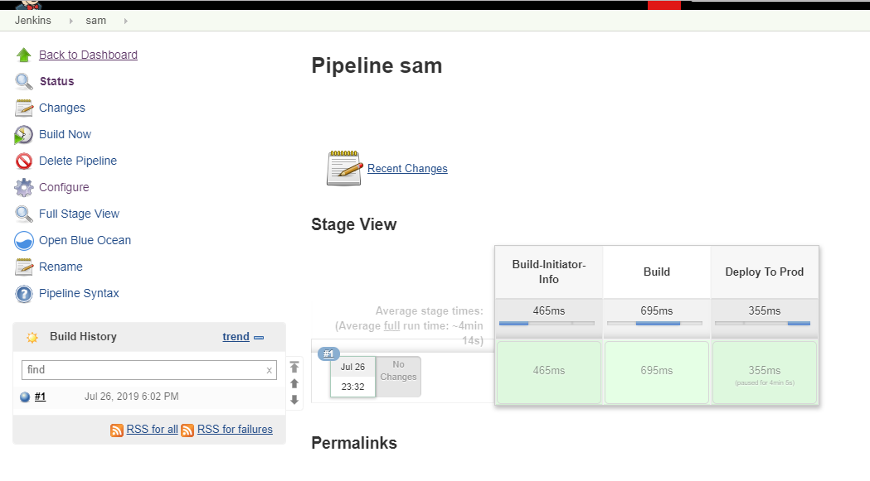

Finally , the files were deployed after being successfully approved before undergoing deployement job.

